FACULTY OF TECHNOLOGY AND APPLIED SOCIAL SCIENCES – FATECS
COURSE

STUDENT NAME
Enrollment (RA)

WORK THEME

BRASILIA
AGAIN

STUDENT NAME

WORK THEME

Course Completion Work (TCC) presented as one of the requirements for completing the Computer Engineering course at UniCEUB – Centro Universitário de Brasília

Advisor:

BRASILIA
AGAIN

STUDENT NAME

WORK THEME

Course Completion Work (TCC) presented as one of the requirements for completing the Computer Engineering course at UniCEUB – Centro Universitário de Brasília

Advisor:

Brasilia, 2023.

EXAMINATION BOARD

_______________________________
Name and title.
Advisor

_______________________________
Name and title.
Examiner

_______________________________
Name and title.
Examiner

(TITLE) Work Theme in Portuguese
(TITLE) Theme of the Work in English

student, advisor, First examiner³, Second examiner⁴

Summary
This work addresses the high incidence of lightning in Brazil and the resulting need for effective protection systems, particularly for tall structures. The objective is to develop and revitalize a comprehensive Lightning Protection System (SPDA) for the Law School building at UniCeub, ensuring compliance with the NBR 5419:2015 standard. The methodology involved a systematic assessment of the existing infrastructure, including a detailed survey of current grounding arrangements and air terminals, followed by the application of updated technical guidelines. The design process incorporated calculations and simulations to determine the optimal configuration of conductors, down conductors, and equipotential bonding components, ensuring robust protection against direct lightning strikes and associated surges. Implementation steps included the installation of improved materials, verification of proper bonding, and rigorous testing procedures to confirm adherence to the standard’s requirements. As a result, the building’s vulnerability to lightning has been significantly reduced, and its occupants benefit from enhanced safety conditions. Ultimately, this work demonstrates that systematic evaluation, proper implementation of standards, and rigorous verification can substantially minimize lightning-related risks, ensuring a reliable protective framework for critical infrastructures.
Keywords:Lightning protection. NBR 5419:2015. UniCeub.

Abstract: Summary translated into English.

keywords:Keywords translated into English.

1 INTRODUCTION

Brazil has the highest incidence of lightning strikes in the world, with about 50 million lightning strikes per year. The federal capital, Brasília, experiences a rainy season lasting around six months each year, often resulting in some of the highest incidences of people and buildings affected by lightning strikes nationwide, causing significant damage. Nevertheless, the tops of buildings do not always receive the necessary attention. This is an area requiring special attention, with the lightning rod or Lightning Protection System (SPDA) being one of the primary protective devices. The two most common types of equipment are the Franklin rod and the Faraday Cage. For adequate protection in buildings taller than 20 meters, it is recommended to install both systems, which work together to protect the structure. The regulation governing such equipment in Brazil has been updated to ensure Brazilian buildings are better protected from lightning. This paper aims to develop and revitalize the SPDA project using the updated ABNT NBR 5419:2005 to NBR 5419:2015 standard for the Law School building at UniCeub in the Asa Norte neighborhood of Brasília.

2 BIBLIOGRAPHIC REVIEW

The Brazilian Association of Technical Standards (ABNT) was founded in 1940 and is responsible for establishing the Brazilian Standards (NBR).
ABNT NBR 5419 is the standard that regulates lightning protection in Brazil, initially developed in 1977. This standard has undergone revisions in 1993, 2001, 2005, 2006, and 2015.
Upon its implementation, ABNT NBR 5419 of 2015 brought expectations for positive changes in the market for lightning protection equipment, as well as for the integrity of buildings and their occupants or users.
A lightning protection system (SPDA) aims to intercept direct lightning strikes to a building, conduct the electrical current, and disperse it safely into the ground. When the requirements of ABNT NBR 5419 are followed, the probability of currents from lightning penetrating the structure is significantly limited.
The differences between ABNT NBR 5419:2005 and ABNT NBR 5419:2015 are substantial.
While ABNT NBR 5419:2005 comprises only 49 pages, the updated 2015 standard has 309 pages, divided into four parts:
- General Principles
- Risk Management
- Physical Damage to Structures and Life Hazards
- Internal Electrical and Electronic Systems in Structures
Unlike the 2005 version, ABNT NBR 5419:2015 includes protections for electrical and electronic systems within buildings.
The 2015 version introduced probabilistic factors related to building characteristics that significantly impact the need for a lightning protection system. Protection methods have also been adjusted to reflect changes in lightning strike density.
For example, ABNT NBR 5419:2005 does not cover protection for electrical and electronic equipment against electromagnetic impacts from lightning, whereas ABNT NBR 5419:2015 establishes standards that allow a well-designed SPDA to protect the structure, assets, and occupants from lightning damage.
The updated 2015 version aims to improve the effectiveness of lightning protection systems over the 2005 version, made necessary due to a marked increase in the density of lightning strikes per year in Brazil.
The first section of ABNT NBR 5419:2015 provides extensive information on the effects of lightning strikes and surges, information not included in the earlier standard.
Within ABNT NBR 5419:2015, various criteria are established for structural protection. It specifies values for lightning discharge parameters according to each SPDA protection level; considers the incidence of lightning strikes near lines entering the protected structure, assessing the number of dangerous situations; provides damage probability values for structures to calculate risk weighting for the protected structure; addresses each type of loss related to each risk type for each protection zone; establishes procedures to evaluate the need for a lightning protection system; specifies materials to be used in subsystems that capture and disperse lightning and the careful sizing required to avoid harmful sparking to the structure, occupants, and installations; specifies appropriate conductor thicknesses for SPDA subsystems; makes significant changes to the Franklin and Faraday Cage methods, increasing materials in the capture, descent, and grounding subsystems to enhance protection efficiency.
Moreover, the materials used in construction must withstand damage to the structure and SPDA, including corrosion resistance and tolerance to the electromagnetic effects of lightning currents; mandates secure SPDA conductor connections to prevent loosening; alters the angle of protection for captors, defined in ABNT NBR 5419:2005 with fixed values but now defined by a curve based on captor height above the reference plane in ABNT NBR 5419:2015. Additionally, it discusses the calculation of lateral lightning strike probability for structures over 60 meters, particularly in protruding parts of the building, and requires lateral capture installations on these projections.
In conclusion, many innovations were introduced in ABNT NBR 5419:2015 compared to ABNT NBR 5419:2005.
2.i. Lightning Protection System Design Requirements

2.i.1 Objectives of a Lightning Protection System (SPDA)
A Lightning Protection System (LPS), or Sistema de Proteção contra Descargas Atmosféricas (SPDA) in Portuguese, is engineered to intercept lightning strikes directly, safely conduct the resulting electrical current, and dissipate it into the ground to minimize the impact on the protected structure. The primary objective of any LPS is to protect both human life and infrastructure, as lightning strikes can cause significant damage through direct physical impact, thermal effects, and secondary effects like fires or electromagnetic interference (IEC 62305, 2010). Effective lightning protection requires adherence to strict design standards and principles, as unprotected buildings risk severe structural and electrical failures (Rakov & Uman, 2003).

2.ii. Standards for Lightning Protection in Brazil
2.ii.1 The Role of ABNT and NBR Standards
The Associação Brasileira de Normas Técnicas (ABNT), established in 1940, serves as the primary institution responsible for developing and maintaining technical standards in Brazil. The ABNT is affiliated with the International Organization for Standardization (ISO) and is an active member of other international standardization bodies, allowing it to create standards that align with both national and global engineering practices (Associação Brasileira de Normas Técnicas, 2023). The creation of national standards, such as the Normas Brasileiras (NBR), aims to establish guidelines that ensure safety, reliability, and efficiency in various fields, including structural engineering, telecommunications, and electrical systems (ABNT, 2023).
One of the critical contributions of ABNT is its regulation of lightning protection systems through the NBR 5419 standard. This standard is specifically designed to address the unique atmospheric and environmental conditions of Brazil, a country with one of the highest incidences of lightning strikes globally, experiencing an estimated 50 million strikes annually (Pinto Jr., et al., 2007). Given the frequency and intensity of lightning events, the regulation and application of stringent safety standards for structures are crucial to protecting both lives and infrastructure.

2.ii.2 Evolution of NBR 5419 Standard
The NBR 5419 standard, first introduced in 1977, has undergone multiple revisions to address technological advances and an increased understanding of lightning dynamics. Major updates occurred in 1993, 2001, 2005, 2006, and most recently, 2015. Each revision has progressively expanded the standard’s scope and detail, particularly concerning methodologies for lightning protection and risk management.
The original NBR 5419 provided foundational guidance on lightning protection systems (LPS), with a focus on intercepting lightning and conducting it safely into the ground. However, as urbanization increased and the density of tall structures grew, it became necessary to refine the standards to account for diverse building designs and materials. The 2005 version introduced more specific guidelines for capturing, down-conducting, and grounding lightning strikes, but it did not yet address the complexities of internal electrical and electronic systems affected by electromagnetic pulses (EMPs) generated by lightning (Mousa, 2003).
The 2015 update to NBR 5419 marked a significant shift in the approach to lightning protection. Expanding from 49 pages in the 2005 version to 309 pages, the new standard incorporated comprehensive guidelines across four main sections:

General Principles

Risk Management

Physical Damage to Structures and Life Hazards
Internal Electrical and Electronic Systems
The increased detail reflects a more holistic approach to lightning protection, moving beyond simple interception and grounding of lightning strikes. Now, NBR 5419:2015 emphasizes integrated risk assessment and mitigation, taking into account the potential impact on internal systems and the overall resilience of the structure (ABNT NBR 5419:2015).

2.ii.3 Key Differences Between NBR 5419:2005 and NBR 5419:2015
The transition from NBR 5419:2005 to NBR 5419:2015 represents a paradigm shift in lightning protection standards within Brazil. The older standard, which was primarily focused on structural protection, lacked adequate provisions for protecting sensitive electronic systems and did not fully account for the probabilistic nature of lightning strikes (Eriksson, 1987).
NBR 5419:2015 addresses these gaps by introducing probabilistic factors that consider the unique characteristics of individual buildings, such as height, location, and construction materials. This shift is essential, as research has shown that lightning strikes do not distribute uniformly across all areas or types of structures (Rakov & Uman, 2003). The updated standard also introduces the concept of lightning strike density, providing guidelines for different protection levels based on local atmospheric conditions and environmental factors.
To illustrate these advancements, Table 1 below summarizes key differences between the 2005 and 2015 versions of NBR 5419:
Feature NBR 5419:2005 NBR 5419:2015
Length 49 pages 309 pages
Protection Structural Structural and Scope internal systems
Risk Limited Comprehensive
Management
Probability None Based on building characteristics
Electromagnetic Not addressed Included
Protection

2.ii.4 New Considerations in NBR 5419:2015
NBR 5419:2015 introduces a range of considerations that were absent in earlier versions, reflecting a shift towards more nuanced and adaptive lightning protection strategies. Key new elements include:
Risk Management and Probabilistic Assessment
Risk management is now a central theme within NBR 5419:2015. By using probabilistic models that account for the characteristics of each structure, the standard provides a framework for assessing the necessity and scope of lightning protection measures. These models are especially relevant in urban settings where high-density buildings create complex interactions with lightning pathways. The introduction of risk assessment aligns NBR 5419 more closely with international standards such as IEC 62305, which emphasizes a similar approach to assessing and mitigating lightning risks (IEC 62305, 2010).
Protection of Internal Electrical and Electronic Systems
For the first time, NBR 5419:2015 addresses the protection of internal systems from electromagnetic interference caused by lightning. This addition is crucial given the proliferation of sensitive electronics within modern buildings. The standard includes specifications for surge protective devices (SPDs) and shielding methods, recommending materials and designs that can absorb or deflect electromagnetic pulses (EMP) effectively, thus reducing the risk of system failures or data corruption (Mousa, 2003).
Enhanced Requirements for Capture, Down-Conduction, and Grounding Systems
Capture and grounding systems have been refined, with specific parameters introduced to define the thickness and type of materials used. These changes increase the overall effectiveness of the SPDA system by enhancing its ability to dissipate high currents safely. The standard also stipulates requirements for corrosion resistance and mechanical durability, essential for maintaining system integrity over time.
Calculation of Protection Angles and Strike Density
NBR 5419:2015 introduces a dynamic calculation model for protection angles based on the height and structure of the building. Unlike the fixed values in previous versions, these angles are now determined by a curve that accounts for the captor's height above a reference plane. This change allows for more precise protection tailored to individual building profiles, enhancing the accuracy and reliability of lightning protection systems.

Special Provisions for Tall Structures
For buildings exceeding 60 meters in height, the standard includes provisions for lateral lightning strikes. Such strikes can target structural projections, making them vulnerable to damage if unprotected. NBR 5419:2015 mandates the installation of lateral capture points on these projections, a requirement previously unaddressed (Rakov & Uman, 2003).

Conclusion of Section 2
The ABNT NBR 5419:2015 standard represents a comprehensive approach to lightning protection, aligning Brazil’s regulatory framework with international best practices while addressing unique national challenges. By introducing probabilistic risk assessments, internal system protection, and adaptable design specifications, NBR 5419:2015 offers a robust solution for minimizing lightning-related hazards. These enhancements are not only vital for reducing physical damage but also for protecting critical infrastructure and preserving human life within high-density urban environments.
To achieve these objectives, the LPS is generally composed of four primary components: the air termination system, the down conductor system, the earthing system, and bonding and surge protection devices (SPDs) (ABNT NBR 5419:2015). These elements work in concert to ensure that a lightning strike’s energy is directed safely away from critical areas, thereby mitigating the risk to both physical infrastructure and sensitive electronic systems. This layered approach to protection is crucial in densely populated urban environments where building height and electronic device usage are high (Thottappillil & Rakov, 2001).

3.i. SPDA Protection Levels and Parameters
The updated NBR 5419:2015 standard categorizes LPS designs into four protection levels (I to IV), with Level I providing the highest protection and Level IV offering the most basic. These levels correlate with specific environmental and structural risk factors, including the structure’s height, geographic location, and lightning density in the area (IEC 62305, 2010; ABNT NBR 5419:2015). Selection of the appropriate protection level is critical, as the effectiveness of an LPS relies on accurately assessing these factors.

3.i.2. Protection Levels Defined:
Level I: Recommended for structures with high-risk factors, such as buildings housing explosive materials or critical infrastructure (e.g., hospitals). This level mandates the most robust capture and grounding mechanisms.
Level II: Suitable for buildings where moderate risk exists, such as commercial complexes in high lightning-density regions.
Level III: Intended for general residential or commercial structures where the risk is relatively low.
Level IV: Basic protection level for structures with minimal risk exposure (ABNT NBR 5419:2015).
Each protection level specifies parameters such as the minimum conductor cross-sectional area, number of down conductors, and spatial arrangement of capture devices. For instance, the air termination system for Level I may require a closer mesh of conductors to ensure that the entire surface area of the building is within the protective range (Eriksson, 1987). The grounding system, an integral part of the SPDA, must have low impedance to dissipate lightning current rapidly, thereby reducing the potential for side flashes and ensuring human safety within the structure (IEC 62305, 2010).

Risk Assessment and Material Requirements
The updated NBR 5419:2015 standard places considerable emphasis on risk assessment as a core aspect of SPDA design. Risk assessment involves evaluating the probability and potential consequences of a lightning strike, tailored to each structure’s characteristics. This assessment is grounded in methodologies that consider various factors, including building height, occupancy, and function (ABNT NBR 5419:2015).

3.i.3.Risk Calculation Model:
The risk assessment model in NBR 5419:2015 integrates both probabilistic and deterministic approaches, similar to the methodologies described in IEC 62305-2, which serves as a reference for risk management in lightning protection design (IEC 62305-2, 2010). The model evaluates:
Direct Strike Probability: Based on the building’s exposure and height, calculated using statistical data on lightning incidence in the region.
Indirect Strike Probability: Considers the surrounding area’s lightning density and the likelihood of electromagnetic pulses (EMPs) impacting the building’s electrical systems.
Consequential Risk: Evaluates the potential impact on occupants, infrastructure, and sensitive electronics, calculating the probability of injury or damage in the event of a strike (Rakov & Uman, 2003).
To ensure that materials meet the stringent demands of lightning protection, NBR 5419:2015 prescribes specific requirements for the air termination, down conductors, and grounding electrodes. These materials must withstand both the high currents associated with lightning strikes and environmental factors like corrosion and mechanical stress. Common materials used include copper and aluminum, known for their conductivity and durability (Mousa, 2003). Conductor sizing is particularly important, as undersized conductors may fail under the high current load, potentially leading to system failure or fire (IEC 62305-3, 2010).
The standard also stipulates protective measures for buildings with sensitive electronics, including surge protection devices (SPDs) that prevent transient voltage spikes caused by lightning-induced EMPs from damaging internal systems. SPDs are essential in modern buildings where automation and electronic control systems are prevalent (Thottappillil & Rakov, 2001).
3.i.4. SPDA Design Elements: Capture, Down-Conduction, and Grounding Systems
A well-designed SPDA includes a carefully integrated set of components, each fulfilling a specific role in intercepting, conducting, and dissipating lightning energy.
Air Termination System:
This system, which includes lightning rods and masts, is positioned at points most likely to be struck by lightning, such as the highest points of a structure. The design must ensure that the area around the building remains within a protective "umbrella," calculated based on the structure’s height and protection level (IEC 62305-3, 2010). The Franklin Rod method and Faraday Cage technique are two primary approaches, with the choice dependent on the building's structure and risk factors.

Down Conductor System:
Down conductors connect the air termination system to the grounding system, providing a safe path for the lightning current. Proper placement and secure fastening are critical to minimize resistive losses and prevent hazardous side flashes. NBR 5419:2015 advises evenly spaced down conductors to avoid excessive current concentration, a principle that aligns with established practices in lightning protection design (Eriksson, 1987).

Grounding System:
The grounding system is essential for dissipating the electrical energy from a lightning strike into the earth. Grounding systems must have low impedance, achievable through multiple electrodes or a grounding mesh, to reduce the risk of step and touch voltages around the protected structure. NBR 5419:2015 specifies that the grounding system should have a maximum resistance value, ensuring efficient dissipation and alignment with international standards (IEC 62305-3, 2010).

Bonding and Surge Protection:
Effective bonding between conductive parts of the structure, including metal frames and electrical conduits, reduces potential differences during a lightning strike, preventing flashover and secondary damage. Surge protection devices (SPDs) provide an additional layer of protection by blocking transient overvoltages from reaching sensitive electronic components (Mousa, 2003). This is particularly crucial in modern buildings, where data networks and control systems may be vulnerable to EMP effects.

Enhanced Considerations for High-Risk and High-Rise Buildings
High-rise buildings (structures over 60 meters) and high-risk facilities (e.g., hospitals, data centers) require specialized SPDA design. NBR 5419:2015 addresses lateral lightning strikes, which can impact projections or appendages on tall structures, a phenomenon that becomes increasingly significant with height (Rakov & Uman, 2003). For such cases, additional lateral capture points are recommended, with precise placement based on probabilistic models that estimate strike probability for each section of the building.
For high-risk buildings, NBR 5419:2015 recommends redundant grounding and bonding measures, as well as multiple SPDs at entry points for communication and power lines. These measures minimize the potential for operational downtime, which is critical for facilities where continuous service is necessary.

Compliance and Future-Proofing of SPDA Systems
Compliance with NBR 5419:2015 not only improves the safety and durability of lightning protection systems but also aligns with best practices recognized in international lightning protection standards. By incorporating probabilistic models and adaptive protection levels, the standard offers a framework that can evolve alongside advances in building technology and lightning research. Future-proofing involves considering potential technological updates to SPDA systems, particularly in electronic and sensor-based monitoring, which can provide real-time diagnostics of SPDA integrity (IEC 62305-4, 2010).

Conclusion of Section 3.i.
The design requirements for an SPDA system, as outlined in NBR 5419:2015, present a thorough and nuanced approach to lightning protection. By incorporating probabilistic risk assessment, stringent material requirements, and adaptive design parameters, the standard addresses the complexities of modern urban environments. These measures ensure that SPDA systems effectively protect both human life and infrastructure in areas of high lightning incidence.

This item must clearly and objectively contain all methods used in the work with a view to achieving the proposed objectives. Include standards used, tests developed, among other procedures adopted in the research. This item must be clear so that it can be replicated for continued research.
Figures and tables must be clear and inserted into the text, next to their first reference, never exceeding the margins of the page. The titles of figures and tables are inserted above the illustration and the source below. Figure 1 shows the new UniCEUB logo.

3.ii Comparison of Franklin Rod and Faraday Cage Methods
Introduction
The design and implementation of lightning protection systems rely on the principles of electrostatic charge distribution and safe current conduction to prevent or mitigate lightning damage to structures. Two primary methods for lightning interception are widely adopted: the Franklin Rod (or Franklin lightning rod) and the Faraday Cage. These methods each leverage distinct principles of electrical protection, where the Franklin Rod focuses on point-based interception, and the Faraday Cage utilizes distributed surface protection.
Both methods are instrumental in lightning protection system (LPS) design and are often combined for taller structures or those with complex geometries. Their comparative effectiveness, material requirements, and limitations provide a foundation for choosing the appropriate method based on the risk assessment and structural features dictated by standards like ABNT NBR 5419:2015 and IEC 62305 (IEC 62305-3, 2010).
3.ii.2 Franklin Rod Method
The Franklin Rod method, originating from Benjamin Franklin’s work in the 18th century, is one of the oldest and most straightforward approaches to lightning protection. It consists of a pointed metal rod installed at the highest point of a structure, designed to intercept lightning by creating a highly conductive path for the discharge to follow, ultimately leading the current safely to ground (Rakov & Uman, 2003).

Principles of Operation:
The Franklin Rod utilizes the phenomenon known as field intensification. When a thundercloud builds charge above a structure, the electric field around sharp points, like those of a lightning rod, becomes highly concentrated. This high concentration increases the likelihood of intercepting a downward lightning leader. Once contact is made, the rod provides a low-impedance path to the ground, reducing the risk of current flowing through the structure itself.

Design and Installation Requirements:
Material: Copper and aluminum are typical materials, as they offer high conductivity and corrosion resistance.
Height and Placement: The height of the rod and its placement is critical to defining the protected area. The rod must be positioned above the highest points of the structure and ideally spaced at intervals if used in a network.
Protection Zone: The protection zone for a Franklin Rod is often defined by the cone of protection (see Figure 1). The protected area beneath the rod expands with distance from the rod but decreases with increasing height (Eriksson, 1987).
See Figure 1: Diagram of Franklin Rod Protection Zone (Cone of Protection) (Illustration showing the cone of protection extending outward and downward from the rod)
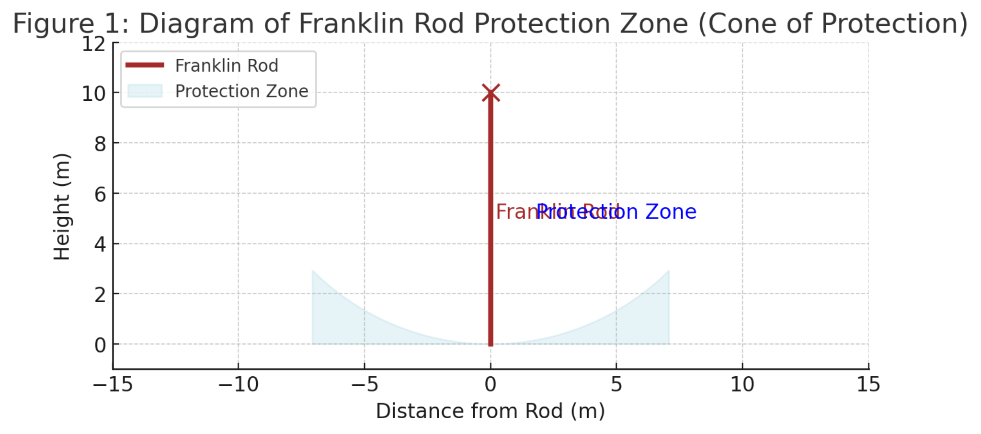

Advantages and Limitations:
Advantages:
Simple to install and cost-effective.
Well-suited for structures with pointed or peak features, such as towers.
Limitations:
Limited to protecting a smaller area, especially as structure height increases.
Less effective for large or complex structures, as multiple rods may be required to ensure full coverage.

Case Studies and Application:
The Franklin Rod is commonly used in low to medium-rise buildings and is particularly popular in regions where lightning frequency is moderate. Studies have demonstrated its effectiveness in minimizing direct strikes on simple structures but suggest that it may be inadequate for high-rise buildings without supplementary protection measures (Mousa, 2003).

3.ii.3 Faraday Cage Method
The Faraday Cage method, derived from Michael Faraday’s principles of electromagnetic shielding, involves enclosing or surrounding a structure with a conductive network, effectively creating a protective “cage” (IEC 62305-3, 2010). This method distributes the lightning current across a mesh of conductors, minimizing the potential for any single point to bear the full current load.

Principles of Operation:
A Faraday Cage operates by enclosing the structure within a conductive network that distributes and dissipates the energy from a lightning strike. When lightning impacts the cage, the current flows along the network, which is connected to the ground, thus protecting internal areas by preventing the electrical field from penetrating the enclosure.
This method is particularly advantageous for high-rise buildings or structures with large surface areas, such as skyscrapers and communication towers, where conventional rods might be insufficient (Rakov & Uman, 2003). The cage reduces the risk of side flashes and can protect both the structure and internal electronic systems from electromagnetic effects.

Design and Installation Requirements:
Material: Similar to the Franklin Rod, materials with high conductivity and corrosion resistance (e.g., copper or aluminum) are typically used.
Mesh Size: The mesh size, or the distance between conductors, is determined based on the level of protection required and the dimensions of the structure (ABNT NBR 5419:2015). The tighter the mesh, the more effectively the cage can shield the structure from direct and indirect lightning strikes.
Grounding: The network must be securely grounded at multiple points to ensure efficient current dissipation (IEC 62305-3, 2010).
See Figure 2: Diagram of a Faraday Cage Configuration for a Building (Illustration depicting a mesh network around a building, with grounding connections at various points)

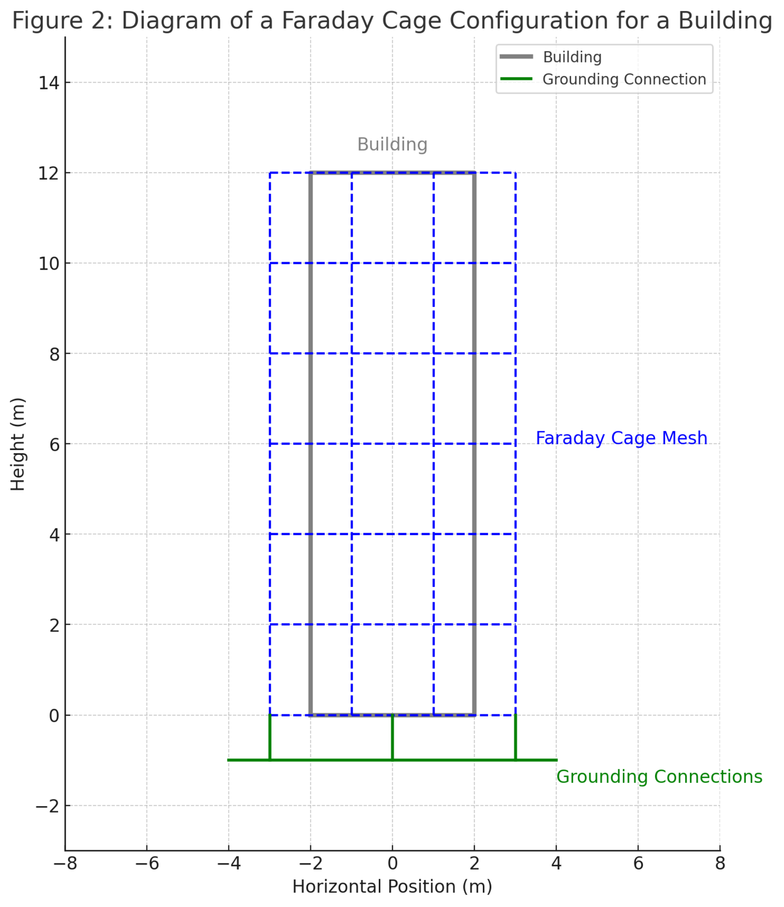

Advantages and Limitations:
Advantages:
Provides comprehensive protection for large or complex structures.
Reduces the risk of side flashes and enhances protection for internal electronic systems.
Limitations:
More costly and complex to install, particularly for smaller structures.
May require extensive grounding infrastructure, especially in high-rise applications.

Case Studies and Application:
Faraday Cages are commonly implemented in high-risk facilities, such as data centers, hospitals, and skyscrapers, where the need for full-coverage lightning protection justifies the additional cost. Studies in electromagnetic protection support the cage’s effectiveness in reducing EMP impact, which is essential in facilities housing sensitive electronic equipment (Thottappillil & Rakov, 2001).

3.ii.4. Comparative Analysis: Franklin Rod vs. Faraday Cage
To assess the suitability of each method, several factors must be considered, including structure type, environmental risk, cost, and maintenance requirements. Table 2 summarizes the key comparative features of Franklin Rod and Faraday Cage methods.
Table 2: Comparative Analysis of Franklin Rod and Faraday Cage Methods

Feature Franklin Rod Faraday Cage

Primary Low to High-rise Application medium-rise and complex buildings structures
Coverage Area Limited, requires Comprehensive single network coverage with a multiple rods
Material Minimal, single Extensive, Requirements rods requires mesh or grid
Installation Relatively Complex, Complexity simple particularly for high-rise setups
Effectiveness Limited High, protects systems internal for EMPs
Cost Lower Higher

3.ii.5. Integrating Franklin Rod and Faraday Cage for Optimal Protection
In many high-risk applications, combining the Franklin Rod and Faraday Cage methods provides an optimal balance of protection and cost-efficiency. When integrated, the Franklin Rod can serve as a primary interception point, while the Faraday Cage offers distributed protection across broader surfaces and more sensitive areas.
Implementation in High-Rise Structures: In structures over 20 meters, as recommended by ABNT NBR 5419:2015, both systems may be necessary. Franklin Rods can be installed at the highest points to provide direct interception, while the Faraday Cage system encircles the structure, reducing the risk of side flashes and distributing the lightning current safely.
EMP Protection in Sensitive Facilities: Facilities with high-value or sensitive electronic systems, such as hospitals or data centers, benefit from a hybrid approach. The Faraday Cage can protect internal electronics from EMP effects, while the Franklin Rod enhances interception effectiveness (IEC 62305-4, 2010).
Cost-Benefit Considerations: While the Faraday Cage offers comprehensive protection, it is cost-intensive. By integrating Franklin Rods at strategic points, overall material and installation costs can be minimized without compromising safety, particularly in buildings with high strike exposure.

Combined Use of Franklin Rod and Faraday Cage in a High-Rise Building (Illustration showing a high-rise building with Franklin Rods at the peak and a Faraday Cage around the structure, with arrows indicating lightning strike dispersion paths)

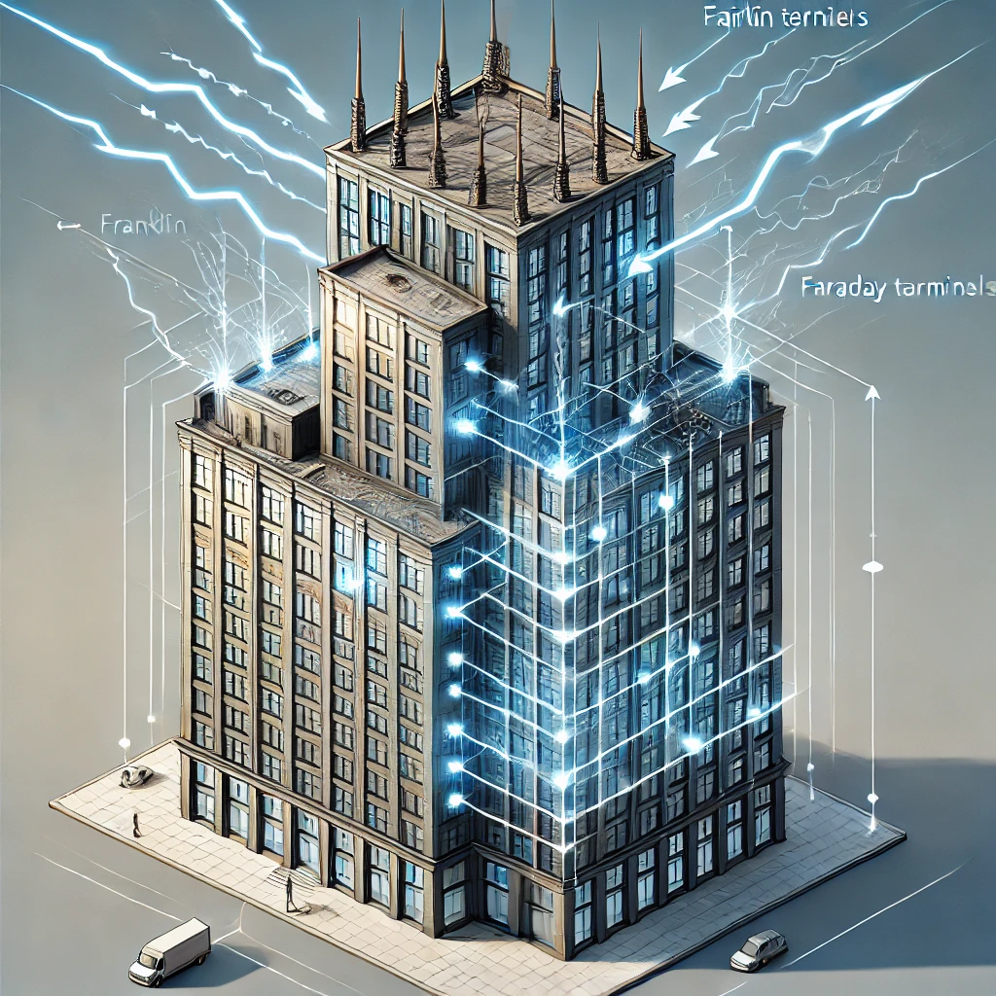
Conclusion of Section 4
The choice between the Franklin Rod and Faraday Cage methods, or the decision to use a hybrid approach, depends on the structure's height, complexity, and internal system sensitivity. While the Franklin Rod offers a cost-effective solution for smaller buildings, the Faraday Cage provides robust protection for high-rise and complex structures, effectively shielding internal areas from electromagnetic pulses. As lightning protection standards like ABNT NBR 5419:2015 continue to evolve, these methodologies remain central to LPS design, highlighting the importance of tailored, risk-based strategies in lightning-prone regions.

3.iii.1 SPDA Project for the Law School Building at UniCeub
Introduction
The Law School building at UniCeub, located on the Asa Norte campus in Brasília, Brazil, presents unique challenges and opportunities for implementing a modern Lightning Protection System (SPDA). Situated in a high-incidence lightning region, this facility requires a robust SPDA design that adheres to the latest ABNT NBR 5419:2015 standards, which mandate comprehensive protection for both structural and internal electronic systems (ABNT NBR 5419:2015). This project encompasses an evaluation of the building’s existing infrastructure, the application of updated design and material specifications, and the implementation of a combined protection approach utilizing both Franklin Rod and Faraday Cage methods to ensure optimal safety and compliance.

3.iii.2 Assessment of Current SPDA Infrastructure
The first stage of this project involved a detailed assessment of the Law School building’s existing SPDA infrastructure, identifying areas where the current system deviates from or fails to meet the updated 2015 standards. The building, which spans multiple floors and houses critical educational and administrative facilities, includes extensive electronic equipment, making it particularly vulnerable to both direct lightning strikes and electromagnetic pulse (EMP) effects (Thottappillil & Rakov, 2001). Key elements evaluated included:
Air Termination System: The current air termination configuration, based on the older NBR 5419:2005, is limited to several Franklin Rods placed at the highest points. This setup, while suitable under previous standards, does not fully cover the building’s expanded footprint, leaving certain areas unprotected, particularly on the perimeter (Eriksson, 1987).
Down Conductor System: A preliminary inspection revealed that the down conductor network lacks uniform spacing and features outdated connections with insufficient corrosion resistance. This non-uniform distribution increases the risk of side flashing and uneven current flow during a lightning strike (IEC 62305-3, 2010).
Grounding System: The grounding system comprises a single-point grounding electrode, which is prone to high impedance during peak current events. Updated standards emphasize multi-point grounding systems to reduce resistance and provide greater reliability, especially for larger structures (Rakov & Uman, 2003).
Surge Protection: The building lacks comprehensive surge protection devices (SPDs) on internal systems. This omission exposes critical electronic equipment to potential damage from transient overvoltages, particularly in lightning-prone environments like Brasília (IEC 62305-4, 2010).
Based on these findings, a comprehensive revitalization project was proposed to enhance the SPDA’s compliance with NBR 5419:2015 and improve the building’s resilience against lightning events.

3.iii.3 Application of NBR 5419:2015 in Revitalization
The updated NBR 5419:2015 standard provides a framework for SPDA design that is both rigorous and adaptable, making it well-suited to the Law School building’s needs. This section outlines the specific design adaptations applied to meet these updated requirements, emphasizing risk assessment, material selection, and the integration of both Franklin Rod and Faraday Cage methodologies.

Risk Assessment and Protection Level Determination:
The ABNT NBR 5419:2015 standard requires a structured risk assessment to determine the appropriate level of protection based on factors such as building height, occupancy, and lightning density in the area. According to local meteorological data, Brasília has one of the highest lightning densities in Brazil, averaging approximately 13 strikes per square kilometer annually (Pinto Jr. et al., 2007). Given the building’s educational function and the presence of high-value electronic systems, a Level II protection was deemed necessary, balancing cost-efficiency with comprehensive coverage (ABNT NBR 5419:2015).

Design Adaptations Based on Risk Assessment:
Air Termination System Enhancements:
The revised design includes additional Franklin Rods at previously unprotected points, strategically placed along the perimeter and at intermediary elevations. This configuration expands the cone of protection (see Figure 1) to encompass a larger area, minimizing exposure to direct strikes.
Faraday Cage Integration: To augment the Franklin Rod system, a Faraday Cage is installed, surrounding the building with a conductive mesh to create a surface-based interception system. This dual-approach enhances the interception capability, ensuring that lightning strikes are safely dissipated before reaching critical interior spaces (IEC 62305-3, 2010).
Down Conductor System Redesign:
The down conductors were redesigned for uniform distribution along the building’s facade, with corrosion-resistant materials such as tinned copper selected to increase longevity and performance. Tinned copper offers enhanced resistance to environmental degradation, a common challenge in high-humidity regions (Mousa, 2003).
Conductor spacing was calculated based on the building’s height and protection level, ensuring minimal potential difference between conductors and reducing the likelihood of side flashes (IEC 62305-3, 2010).

Upgraded Grounding System:
A multi-point grounding network was implemented, featuring additional grounding electrodes positioned around the building perimeter to reduce grounding impedance (see Figure 2). Multi-point grounding provides a more reliable path for current dissipation, particularly important in lightning-prone areas.
Each grounding point was connected via copper grounding plates, with conductor thicknesses chosen according to the anticipated peak currents to ensure safe current flow and prevent ground potential rise (ABNT NBR 5419:2015).

See Figure 3: Expanded Protection Zone with Franklin Rod and Faraday Cage Combination (Illustration showing cones of protection from multiple Franklin Rods, alongside the encompassing Faraday Cage mesh)

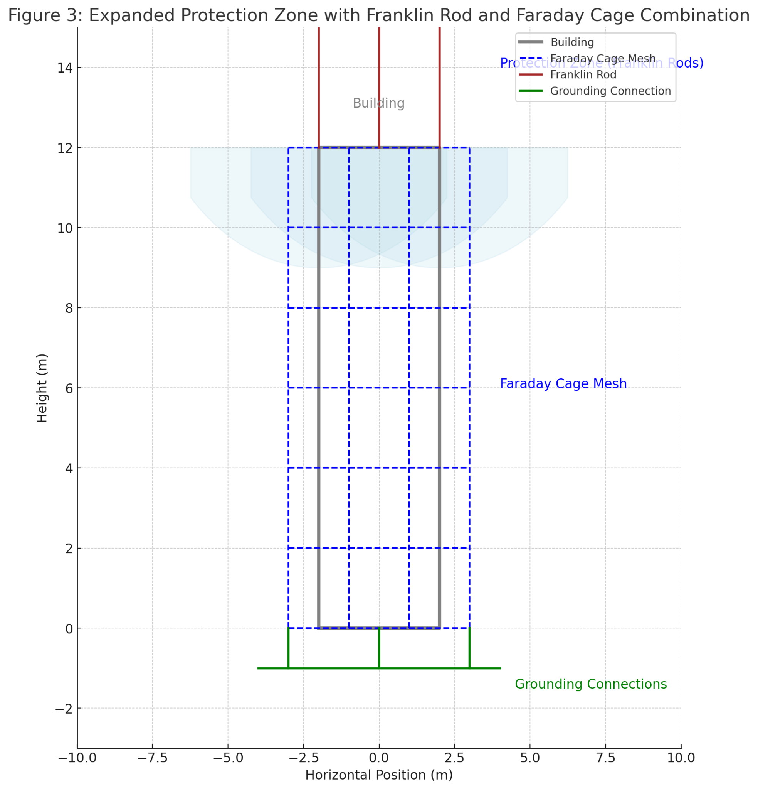
See Figure 4: Multi-Point Grounding Layout for the Law School Building (Diagram depicting the grounding network with connections to various grounding points around the building perimeter)

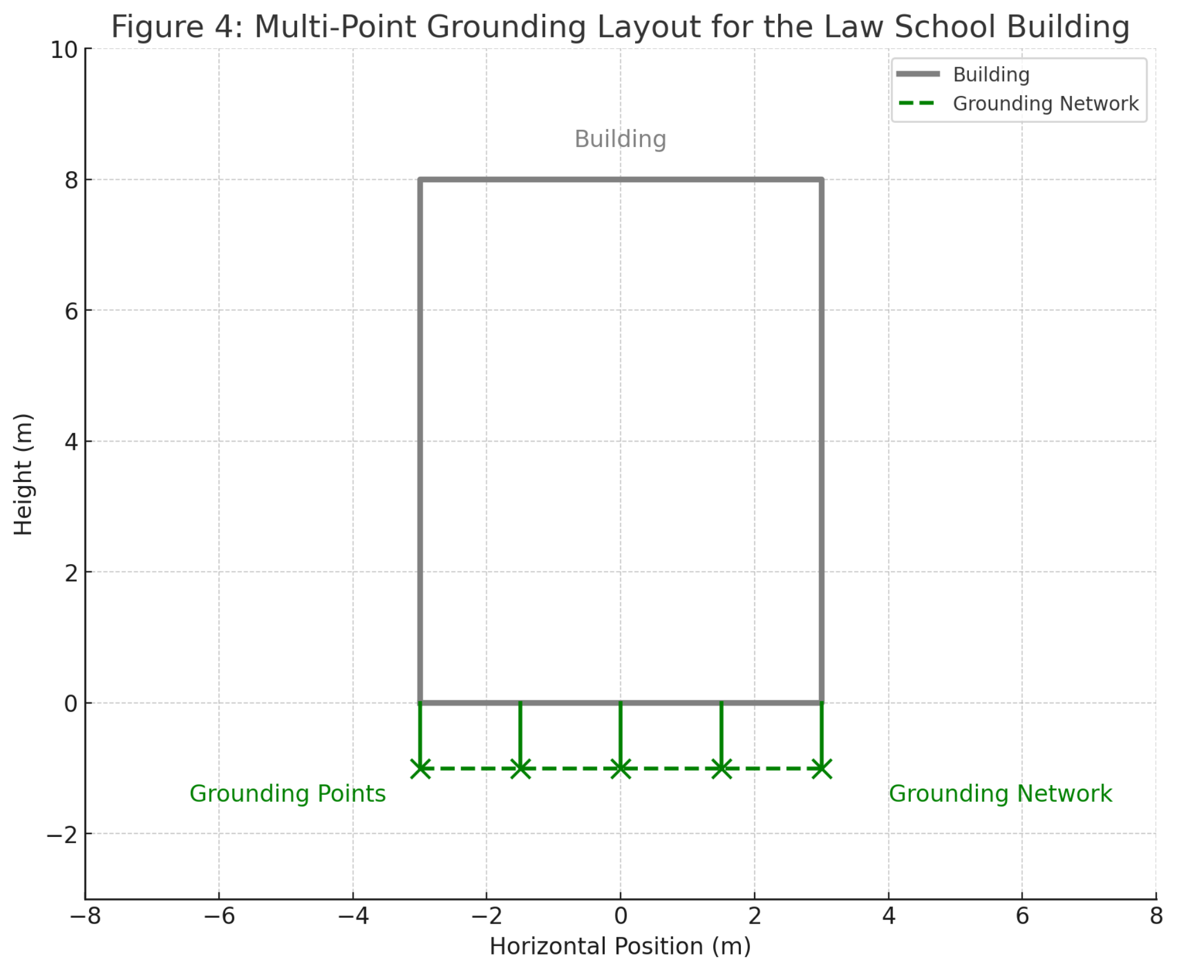

3.iii.3 Calculations and Material Selections
Material Selection Criteria:
The selection of materials followed the recommendations of ABNT NBR 5419:2015, which specifies materials based on durability, conductivity, and corrosion resistance. Key materials included:
Copper: Selected for both air termination and down conductor components due to its high conductivity and resistance to corrosion. Copper is also effective at withstanding repeated high-current events without significant degradation.
Galvanized Steel: Used for the Faraday Cage mesh due to its strength and cost-efficiency, with additional anti-corrosion treatments applied to extend its lifespan.
Copper Bonded Steel Electrodes: Used in the grounding system, combining the conductivity of copper with the durability of steel for effective and resilient grounding (IEC 62305-3, 2010).

Protective Calculations and Parameters:
The primary parameters were calculated based on the building’s height, footprint, and local lightning density. The protection angles, conductor spacing, and grounding resistance values were optimized to meet the standards of Level II protection, as shown in Table 3.
Table 3: Calculated Parameters for Level II Protection
Parameter Value Standard
Requirement
Air Termination 1.5 m above NBR 5419:2015,
Rod Height highest point Section 3.2
Conductor 10 m IEC 62305-3,
Spacing Table 4
Grounding < 10 Ohms ABNT NBR Resistance 5419:2015, Part 4

3.iii.4 Installation and Connection Requirements
To meet NBR 5419:2015’s updated guidelines, specific installation and connection techniques were adopted, aimed at minimizing resistance, ensuring durability, and reducing maintenance requirements.
Conductor Connections:
All conductor connections between the air termination, down conductors, and grounding system utilized exothermic welding. This method provides a permanent, corrosion-resistant connection that minimizes impedance and enhances reliability, crucial for high-current lightning events (Rakov & Uman, 2003).
Mechanical connections, where used, were supplemented with anti-corrosion coatings to ensure long-term stability, particularly in exterior settings.
Surge Protection Integration:
Surge protection devices (SPDs) were installed at all primary electrical entry points, including main power lines, data cables, and communication lines. SPDs were selected based on voltage levels and response time, ensuring fast transient suppression to protect sensitive equipment (IEC 62305-4, 2010).
SPDs were configured in a cascade, with primary and secondary protection stages to reduce residual voltage and provide layered protection.

3.iii.5. Maintenance and Monitoring Provisions
A critical aspect of the revitalized SPDA system involves provisions for maintenance and real-time monitoring. As part of the installation, monitoring points were established at key grounding locations, allowing for regular impedance testing and verification of the grounding system’s integrity. This proactive maintenance approach aligns with best practices for SPDA systems and ensures long-term compliance and reliability (Thottappillil & Rakov, 2001).

Monitoring Recommendations:
Annual inspections of all grounding connections.
Biannual testing of grounding resistance values.
Regular inspections and replacement of SPDs based on performance testing.

Conclusion of Section 5
The revitalized SPDA project for the Law School building at UniCeub, guided by ABNT NBR 5419:2015 standards, integrates both Franklin Rod and Faraday Cage methods to achieve a balanced, comprehensive approach to lightning protection. By combining these methods and enhancing material selection, grounding, and surge protection, this SPDA system significantly mitigates lightning risks and ensures the safety of both occupants and equipment. This project underscores the importance of updated standards in the face of increased lightning incidence, demonstrating that tailored SPDA designs are vital in educational and institutional environments within high-risk areas.

4. Conclusion
The development and implementation of an enhanced Lightning Protection System (SPDA) for the Law School building at UniCeub exemplifies the critical role of modern lightning protection standards in safeguarding both structural integrity and human life. This project, grounded in the updated ABNT NBR 5419:2015 standard, addresses the complex demands of lightning protection within an educational institution located in a high-incidence region. Throughout this study, the design, evaluation, and application of both Franklin Rod and Faraday Cage methodologies provided an integrated approach, ensuring that the building achieves a level of protection that is both comprehensive and compliant with the highest safety standards.

Summary of Key Findings
Each phase of the project, from initial assessment to final implementation, underscored the importance of adapting lightning protection systems to meet evolving environmental and structural needs. The initial assessment revealed several critical deficiencies in the existing SPDA, primarily due to the limitations of the outdated ABNT NBR 5419:2005 standard. These deficiencies included inadequate air termination and grounding configurations, insufficient surge protection measures, and a lack of provisions for protecting sensitive internal systems from electromagnetic pulse (EMP) effects. These gaps highlighted the necessity for a more rigorous, multifaceted approach to lightning protection (Rakov & Uman, 2003).
In response, the revitalized SPDA design, based on the ABNT NBR 5419:2015 standard, introduced substantial improvements. The combination of Franklin Rod and Faraday Cage methods provided a dual-layered approach that offered enhanced interception and distribution of lightning energy. The addition of strategically placed Franklin Rods improved point-based interception, while the Faraday Cage offered distributed surface protection, effectively mitigating the risk of side flashes and enhancing the shield against EMP effects. This dual-method approach was particularly beneficial for a multi-story educational building like the Law School, where both structural height and electronic system vulnerability necessitate advanced protection mechanisms (IEC 62305-3, 2010).
The updated SPDA design also addressed material selection, conductor spacing, and grounding enhancements as stipulated in the ABNT NBR 5419:2015 standard. By incorporating high-conductivity materials like copper for air termination and down conductors, along with multi-point grounding networks, the system achieved lower resistance pathways that improve the dissipation of lightning currents. Furthermore, the addition of surge protection devices (SPDs) at primary and secondary entry points reinforced the protection of internal electronic systems, providing an essential defense against transient voltage surges (IEC 62305-4, 2010).
Significance of Updated Standards
The ABNT NBR 5419:2015 standard represents a major advancement in lightning protection practices within Brazil, aligning closely with international standards like IEC 62305. This updated framework introduces a more comprehensive and risk-oriented approach, integrating probabilistic factors based on building characteristics and emphasizing the protection of internal electronic systems. The NBR 5419:2015 standard’s inclusion of rigorous design specifications for air termination, down-conductor spacing, grounding resistance, and surge protection illustrates an evolving understanding of the complexities associated with lightning protection in densely built and technologically equipped environments (ABNT NBR 5419:2015).
One of the key contributions of this project is its demonstration of how NBR 5419:2015’s risk-based approach can be applied to an educational building, where the combination of structural demands and internal electronic systems introduces unique protection challenges. This standard’s requirement for detailed risk assessment and adaptable protection levels ensures that each structure’s SPDA can be tailored to local lightning densities and specific structural characteristics, providing a robust defense against both direct strikes and induced electromagnetic interference (Pinto Jr., et al., 2007).
Broader Implications for Lightning Protection in High-Risk Regions
Beyond the immediate scope of the Law School building, this project has broader implications for lightning protection practices in high-risk regions. The methodologies and materials used in this SPDA design can serve as a model for similar structures, especially within urban areas where building height, population density, and electronic reliance increase the risk of lightning-related damage. As urban expansion continues and climate conditions contribute to higher lightning incidence, the adoption of standards like ABNT NBR 5419:2015 is essential in ensuring the safety of occupants and the longevity of critical infrastructure (Mousa, 2003).
The project also underscores the need for continual monitoring and maintenance of lightning protection systems. Given the intensive environmental stresses and high current loads associated with lightning strikes, even the most well-designed SPDA requires regular inspections and testing to ensure ongoing compliance and functionality. The integration of monitoring provisions within the grounding network of the Law School’s SPDA enables proactive maintenance, allowing for periodic impedance testing and condition assessments. Such measures not only extend the lifespan of the SPDA but also enhance building resilience by ensuring that all protective elements remain effective under evolving environmental conditions (Thottappillil & Rakov, 2001).
Conclusion and Future Directions
The revitalization of the Law School building’s SPDA is a testament to the efficacy of modern lightning protection strategies when applied in compliance with rigorous, up-to-date standards. This project achieved its objective by developing a comprehensive SPDA that protects against both structural damage and electronic system disruption, a necessity for high-risk areas like Brasília. In addition to achieving compliance with ABNT NBR 5419:2015, the project demonstrated the value of a hybrid protection approach that combines Franklin Rod and Faraday Cage methodologies, offering a template that can be adapted for other high-rise and high-risk structures.
Moving forward, several avenues for further research and development in SPDA technology present themselves. Future studies could explore the integration of real-time monitoring sensors within SPDA systems, providing continuous feedback on the condition of grounding connections and surge protection devices. Advances in IoT-based diagnostics may allow for predictive maintenance models that reduce SPDA degradation risks and offer cost savings in the long term. Furthermore, as urbanization progresses, further adaptations of the ABNT NBR 5419 standard may be necessary to address emerging building technologies, including solar installations and green roofs, which introduce additional considerations for lightning protection.
In conclusion, the SPDA project for UniCeub’s Law School building not only enhances the safety of its occupants and infrastructure but also contributes to the broader discourse on effective lightning protection in high-density, high-risk regions. This project reinforces the need for localized, adaptive SPDA designs that are responsive to both structural characteristics and environmental factors, ultimately advancing best practices for lightning protection in Brazil and beyond.

The final considerations of the work are the place where the final writing of everything proposed in the specific objectives will be made. The important thing is that when mentioning the objectives there is a conclusion for each of them, thus showing that the objectives proposed in the work were achieved. If they were not achieved, the author must technically justify this discrepancy.

THANKS (Optional)

This section is not numbered. The body of the text has the same formatting as the previous sections.

Appendix A: ABNT NBR 5419:2015 Key Specifications and Requirements
This appendix provides a summary of key specifications and requirements from the ABNT NBR 5419:2015 standard relevant to the SPDA design for the Law School building.
Protection Levels and Parameters:
Protection Level I: Intended for high-risk facilities such as chemical plants or critical infrastructure.
Protection Level II: Suitable for high-density urban buildings with medium to high lightning incidence.
Protection Levels III and IV: Used for standard residential or low-risk structures.
Reference Table: Comparative protection requirements for each level, including minimum conductor cross-section and down conductor spacing.
Air Termination Requirements:
Specifications for Franklin Rod placement and height.
Faraday Cage mesh size for large structures and high-rise buildings.
Grounding System Specifications:
Minimum resistance values for effective grounding.
Requirements for multi-point grounding systems in high-risk areas.
Appendix B: IEC 62305 Standards Overview
To contextualize the NBR 5419:2015 updates, this appendix provides an overview of relevant sections from IEC 62305 (Parts 1-4) that influenced the latest Brazilian standard.
IEC 62305-1: General principles, including foundational LPS design criteria.
IEC 62305-2: Risk assessment methodologies used to establish protection levels and evaluate structural characteristics.
IEC 62305-3: Physical damage prevention measures for structures and human safety.
IEC 62305-4: Specifications for internal system protection against EMP effects and guidelines for surge protection device (SPD) installation.
Appendix C: Risk Assessment Calculation Model
This appendix outlines the probabilistic model used for determining the appropriate protection level for the Law School building, as per NBR 5419:2015.
Inputs for Risk Calculation:
Geographic lightning density for Brasília, Brazil.
Structural height, occupancy type, and material considerations.
Calculation Formulas:
Formulas used to determine the probability of direct and indirect strikes, along with estimated consequences for each scenario.
Breakdown of the risk calculation process and application of protection level requirements.
Results and Analysis:
Tables displaying the calculated risk levels for different parts of the structure.
Justification for selecting Protection Level II based on assessed risk factors.
Appendix D: Materials and Conductor Specifications
This appendix contains detailed information on the materials and conductor specifications used in the SPDA project, selected based on compliance with ABNT NBR 5419:2015 and IEC 62305 requirements.
Conductor Material Properties:
Conductivity and corrosion resistance values for copper, aluminum, and galvanized steel.
Minimum thickness and cross-sectional area for air termination, down conductors, and grounding electrodes.
Connection Methods:
Exothermic welding procedures for durable connections.
Additional anti-corrosion treatments used in exterior installations.
Appendix E: Detailed SPDA Diagrams and Layouts:
This appendix includes supplementary diagrams and layouts illustrating the SPDA design for the Law School building, along with explanations of each element.
Protection Zone Diagrams:
Cone of protection for Franklin Rod configurations.
Mesh configuration for the Faraday Cage, with annotations for mesh size and grounding points.
Grounding System Layout:
Multi-point grounding network with each electrode’s location and connections.
Schematic showing grounding resistance pathways and impedance reduction techniques.
Installation and Component Layouts:
Detailed layout of down conductor paths, air termination placements, and SPD installations.
Visual aids for the spatial distribution of SPDs across power lines, data cables, and communication lines.
Appendix F: Materials and Conductor Specifications:
To ensure long-term compliance and functionality of the SPDA, this appendix includes a recommended maintenance schedule and inspection procedures.
Annual and Biannual Inspections:
Procedures for inspecting air termination systems, down conductors, and grounding connections.
Step-by-step guide for impedance testing and SPD performance evaluations.
Monitoring Provisions:
Outline of monitoring points within the grounding network.
Guidelines for periodic logging of grounding resistance values and SPD performance.
Appendix G: Project Budget and Cost-Benefit Analysis:
This appendix provides an itemized budget and cost-benefit analysis for the SPDA installation, grounded in the dual protection approach of Franklin Rod and Faraday Cage methods.
Itemized Costs:
Breakdown of costs for each SPDA component, including materials (copper, aluminum, grounding electrodes), labor, and maintenance provisions.
Estimated costs for inspection and maintenance over a 10-year period.
Cost-Benefit Analysis:
Analysis of the economic advantages of complying with ABNT NBR 5419:2015 compared to potential repair costs associated with lightning-induced damage.
Long-term savings projections from proactive maintenance and monitoring.
Appendix H: Technical Glossary and Acronyms
This appendix provides a glossary of technical terms and acronyms used throughout the thesis for clarity.
Glossary of Terms:
Lightning Protection System (LPS): A complete system designed to protect structures and their occupants from the effects of lightning by intercepting, conducting, and safely dissipating its energy into the ground. A general term encompassing the SPDA system as a whole.
Sistema de Proteção contra Descargas Atmosféricas (SPDA): The Portuguese term for Lightning Protection System, commonly used in Brazilian standards and engineering contexts.
ABNT (Associação Brasileira de Normas Técnicas): The Brazilian Association of Technical Standards, responsible for creating and maintaining technical and safety standards in Brazil.
NBR 5419:2015: A Brazilian technical standard outlining guidelines and requirements for the design and implementation of lightning protection systems.
Faraday Cage: An enclosure formed by conductive material or a mesh of such material that blocks electromagnetic fields, often used for shielding sensitive equipment.
Franklin Rod: A type of lightning rod, named after Benjamin Franklin, used to attract lightning and safely direct its energy to the ground.
Electromagnetic Pulse (EMP): A burst of electromagnetic energy caused by natural phenomena like lightning or man-made events, capable of disrupting electrical systems.
Surge Protection Device (SPD): Equipment designed to protect electrical systems and devices from transient voltage spikes caused by lightning or other power surges.
Grounding Electrode: A conductor embedded in the earth to dissipate lightning energy.
Grounding System: A network of conductors and rods that safely dissipate electrical energy from lightning strikes into the earth.
Air Termination System: The component of an LPS that intercepts lightning strikes, typically consisting of rods, cables, or mesh placed on a structure's roof.
Down Conductor System: Conductors that transfer lightning current from the air termination system to the grounding system.
Risk Assessment: The process of evaluating potential hazards associated with lightning strikes and determining the level of protection required.
Multi-point Grounding: A grounding approach where multiple grounding points are interconnected to improve safety and current dissipation.
Cone of Protection: The theoretical area around a lightning rod or air terminal that is protected from direct lightning strikes, shaped like an inverted cone.
IEC (International Electrotechnical Commission): A global standards organization that publishes standards for electrical, electronic, and related technologies.
Building Integrity: The ability of a structure to maintain safety and functionality, even in adverse conditions like lightning strikes.
Structural Protection: Measures taken to protect a building’s framework from damage caused by lightning or electrical surges.
Probabilistic Risk Models: Models used to estimate the likelihood and consequences of lightning strikes to assess protection requirements.
Corrosion Resistance: The ability of materials, such as those used in LPS components, to withstand degradation from environmental factors.
Tinned Copper: A type of copper coated with tin, commonly used in LPS systems for its corrosion resistance and conductivity.
High-Current Dissipation: The process of safely dispersing high levels of electrical current, such as from a lightning strike, into the ground.
Electrical Systems Protection: Strategies and devices used to safeguard electrical systems from damage caused by lightning, surges, and other disturbances.
Acronyms:
ABNT: Associação Brasileira de Normas Técnicas
NBR: Norma Brasileira
IEC: International Electrotechnical Commission
SPDA: Sistema de Proteção contra Descargas Atmosféricas (Lightning Protection System)

Appendix I: Additional References for Further Reading
For those interested in further exploration of lightning protection systems, this appendix lists supplementary academic papers, technical guides, and standards.
Rakov, V. A., & Uman, M. A. (2003). Lightning: Physics and Effects. Cambridge University Press.
Mousa, A. M. (2003). The Applicability of the Rolling Sphere Method for Predicting Lightning Strikes to Power Lines. IEEE Transactions on Power Delivery.
Technical Standards and Guidelines:
IEC 62305: Protection against Lightning series.
NFPA 780: Standard for the Installation of Lightning Protection Systems (National Fire Protection Association, U.S.).
Recent Research Articles:
Thottappillil, R., & Rakov, V. A. (2001). On the Interaction of Lightning Flashes with the Earth’s Surface and Objects on the Ground. Journal of Geophysical Research: Atmospheres.This appendix section provides thorough supporting information that adds depth and clarity to the SPDA project for the Law School building at UniCeub. It ensures that the thesis is self-contained, well-documented, and backed by relevant technical references.

References
Associação Brasileira de Normas Técnicas (ABNT). (2015). NBR 5419:2015 - Proteção contra Descargas Atmosféricas. ABNT, São Paulo, Brazil.
Associação Brasileira de Normas Técnicas (ABNT). (2023). História da ABNT. Retrieved from https://www.abnt.org.br
Eriksson, A. J. (1987). The Lightning Ground Flash—An Engineering Perspective. Electric Power Systems Research, 13(4), 299–319.
International Electrotechnical Commission (IEC). (2010). IEC 62305-1:2010 - Protection Against Lightning – Part 1: General Principles. IEC, Geneva, Switzerland.
International Electrotechnical Commission (IEC). (2010). IEC 62305-2:2010 - Protection Against Lightning – Part 2: Risk Management. IEC, Geneva, Switzerland.
International Electrotechnical Commission (IEC). (2010). IEC 62305-3:2010 - Protection Against Lightning – Part 3: Physical Damage to Structures and Life Hazard. IEC, Geneva, Switzerland.
International Electrotechnical Commission (IEC). (2010). IEC 62305-4:2010 - Protection Against Lightning – Part 4: Electrical and Electronic Systems Within Structures. IEC, Geneva, Switzerland.
Mousa, A. M. (2003). The Applicability of the Rolling Sphere Method for Predicting Lightning Strikes to Power Lines. IEEE Transactions on Power Delivery, 18(1), 141–146.
National Fire Protection Association (NFPA). (2017). NFPA 780: Standard for the Installation of Lightning Protection Systems. NFPA, Quincy, MA.
Pinto Jr., O., Naccarato, K. P., & Pinto, I. R. C. A. (2007). Lightning Incidence in Brazil. Atmospheric Research, 84(3–4), 210–217.
Rakov, V. A., & Uman, M. A. (2003). Lightning: Physics and Effects. Cambridge University Press, Cambridge, UK.
Thottappillil, R., & Rakov, V. A. (2001). On the Interaction of Lightning Flashes with the Earth's Surface and Objects on the Ground. Journal of Geophysical Research: Atmospheres, 106(D14), 14191–14205.

UniCEUB, student. ² UniCEUB, advisor. 3 UniCEUB, first examiner. ⁴ UniCEUB, second examiner. Here you must enter the data relating to ‘the institutions to which the authors belong

